Algorithm for file updates in Python

Project description
In this project, I developed a Python algorithm to manage and update an allow list of IP addresses used to control access to a restricted network. The algorithm reads the contents of a text file, converts the stored IP addresses into a list, and compares them against a predefined remove list. Any IP addresses identified in the remove list are removed from the allow list. The updated list is then converted back into a string and written to the original file. This process helps maintain accurate access control and improves the security of the environment.

Open the file that contains the allow list
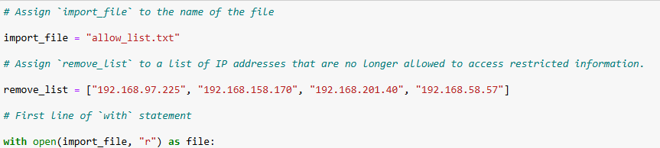

Read the file contents
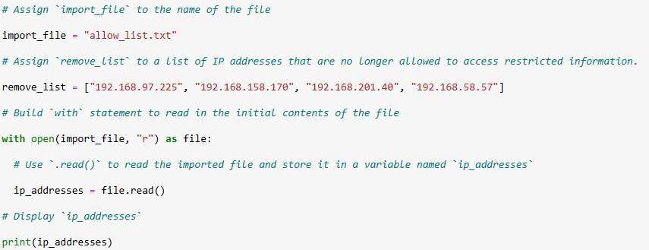

Convert the string into a list
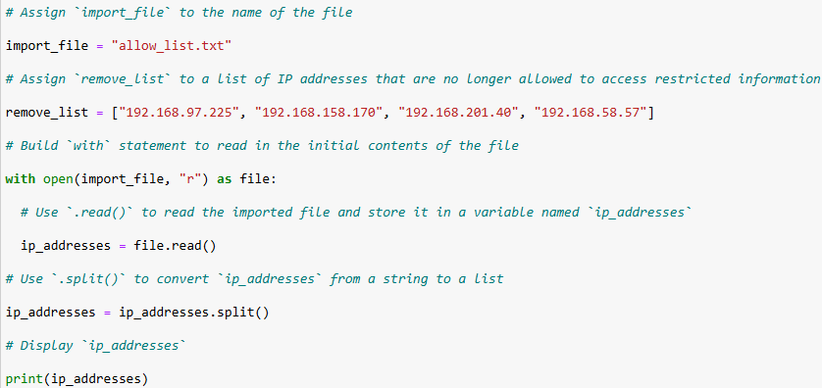

Iterate through the remove list
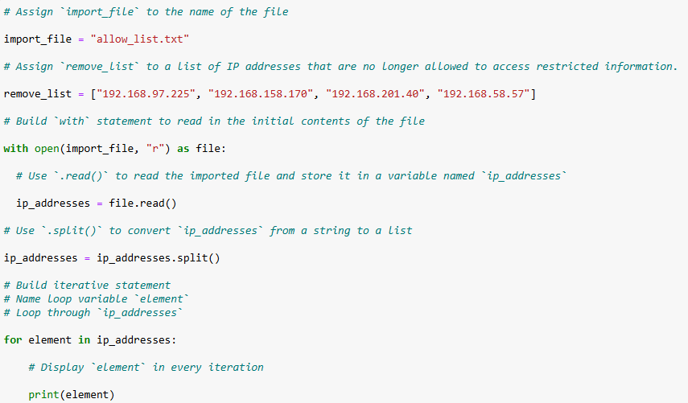

Remove IP addresses that are on the remove list
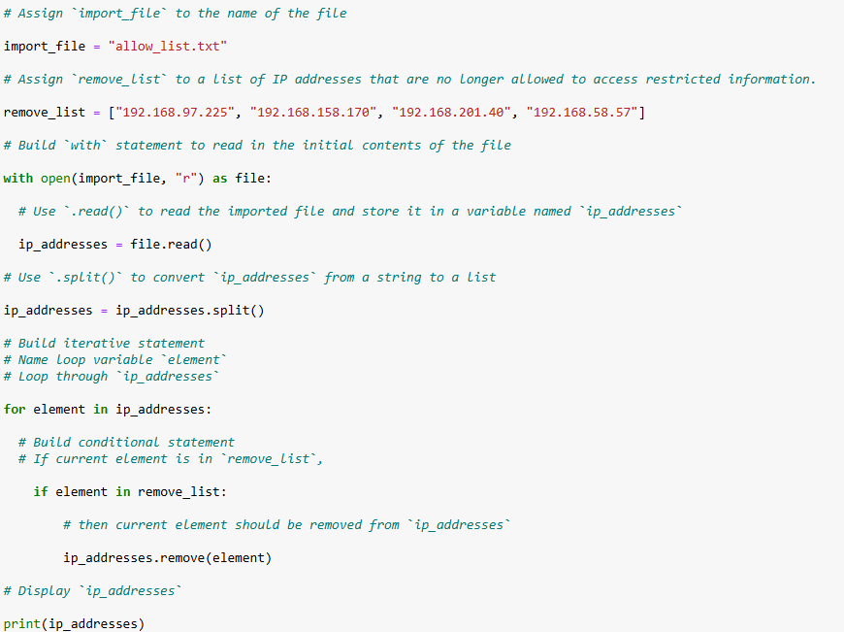

Update the file with the revised list of IP addresses
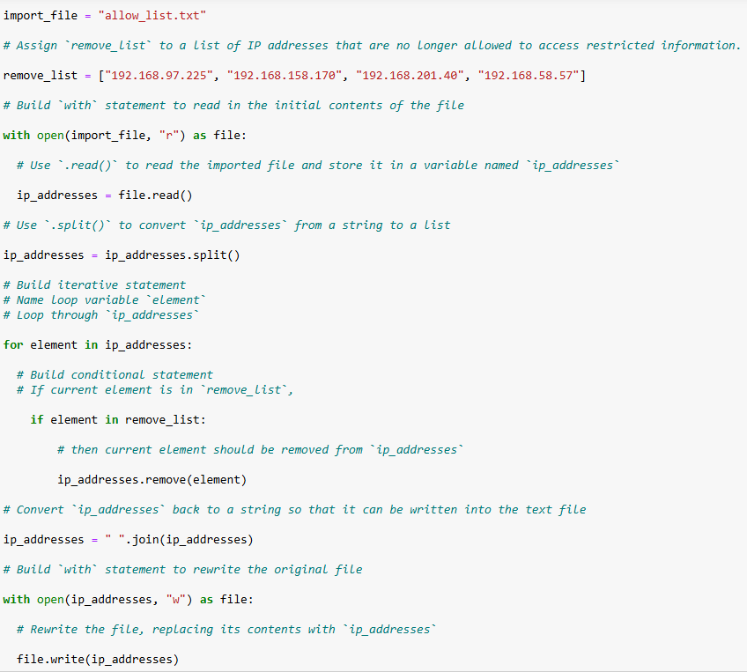

Summary

The algorithm begins by opening and reading a text file that contains approved IP addresses. Next, the data is converted from a string into a list using the `split()` method to enable individual IP address processing. The algorithm then iterates through the list of IP addresses and removes any entries that appear in the remove list. After the necessary updates are made, the remaining IP addresses are converted back into a string using the `join()` method. Finally, the file is overwritten with the updated allow list, ensuring that only authorized IP addresses retain access to the restricted network.

